1.The minimum wiring to program VNCL is given in the table

2.The circuit diagram recommended by the manufacturer is given below

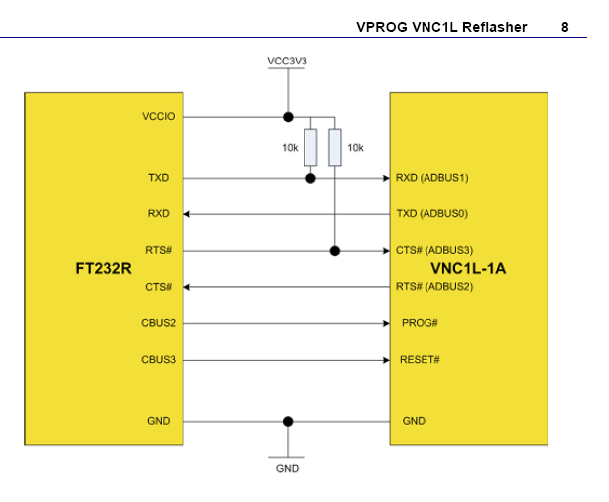

3.There are several methods to program VNCL and the methods are given in the application note.

